**National University of Computer & Emerging Sciences**

**Karachi Campus**

Section: BCS-4J

Instructor Name: Miss Anaum Hamid

Operating System (CS-2006)

**SysLink**

Project Start Date: 15 March 2023

Link: <https://github.com/sufiyaanusmani/SysLink>

QR Code



*Project Report*

* **Introduction:**

Introducing our latest app, specially designed for Linux enthusiasts and developers who seek to take their system administration skills to new heights. This cutting-edge app is tailored to offer a seamless and secure remote connection to your Linux machine via the SSH protocol, enabling you to access and manage your system from anywhere in the world.

But that's not all - our app takes it to the next level by integrating system calls that allow you to execute low-level operations on your machine directly from the app. This feature simplifies the process of managing your Linux system by offering a convenient way to perform advanced tasks and streamline your workflow.

Whether you are a seasoned Linux user or just starting, our app is the perfect tool to enhance your system administration skills. With its user-friendly interface and advanced capabilities, our app enables you to achieve greater efficiency and control over your Linux machine. Join us today and experience the next level of Linux system administration.

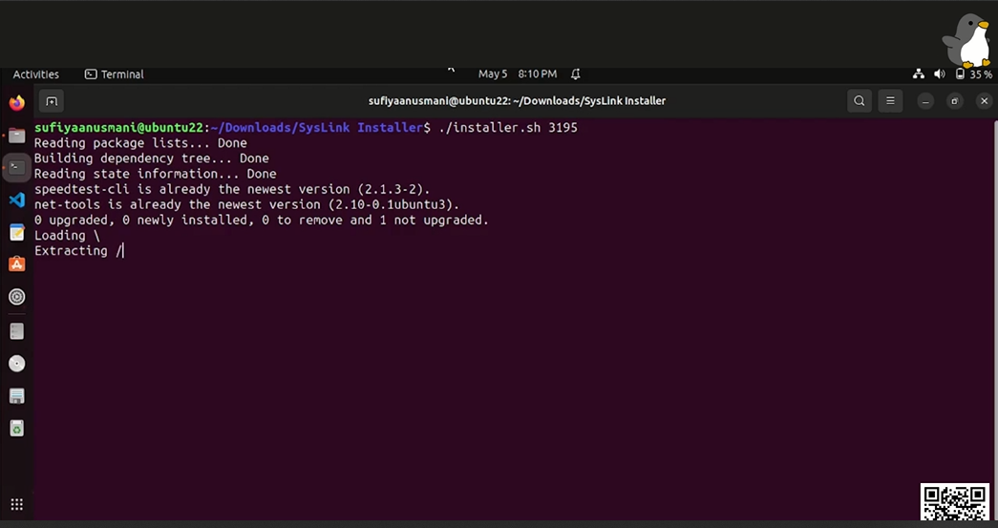

* **Objective:**
* *To develop a user-friendly Linux system administration app that offers a seamless and secure remote connection via the SSH protocol.*
* *To integrate system calls that allow users to execute low-level operations on Linux systems directly from the app.*
* *To simplify the process of managing Linux systems and streamline workflows for system administrators and developers.*
* **Why Is Linux Administration Used?**

*Linux system administration refers to the process of managing Linux-based computer systems, including installation, configuration, maintenance, troubleshooting, and optimization. System administrators are responsible for ensuring that Linux systems are running smoothly and securely, meeting the organization's requirements and users' needs.*

***Why is Linux System Administration Important?***

1. ***Security***: Linux is known for its security features, but it is not immune to attacks. System administrators are responsible for implementing security measures, such as firewall configuration, user authentication, and software updates, to protect Linux systems from external threats.
2. ***Performance***: Linux systems can perform complex tasks efficiently, but their performance can degrade over time due to various factors, such as software conflicts, misconfigured settings, and hardware failure. System administrators are responsible for monitoring system performance and optimizing it to ensure that Linux systems run at peak efficiency.
3. ***Reliability:*** Linux systems are designed to be stable and reliable, but they can encounter issues that can impact their uptime and availability. System administrators are responsible for ensuring that Linux systems are up and running, minimizing downtime and maintaining high availability.
4. ***Scalability***: Linux systems can scale to meet the organization's growing needs, but it requires careful planning and implementation. System administrators are responsible for designing and implementing scalable infrastructure, such as load balancing, clustering, and virtualization, to ensure that Linux systems can handle increasing workloads.

* **Methodology:**

The development of the Linux system administration app involved several stages, including:

1. ***Research:*** We conducted extensive research on Linux system administration, SSH protocol, and low-level system calls.
2. ***Design***: Based on the research findings, we designed the app architecture, user interface, and system calls integration.
3. ***Development***: We used Python and its libraries to develop the app, implementing the designed architecture, user interface, and system calls.
4. ***Testing***: We conducted several tests to ensure that the app is seamless, secure, and efficient in managing Linux systems.

* **FEATURES:**
* ***File manager***: Allow users to browse, manage and manipulate files on their Linux system

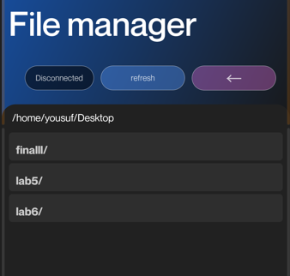

* ***Disk usage analyzer:*** Analyze and visualize disk usage on the Linux system.

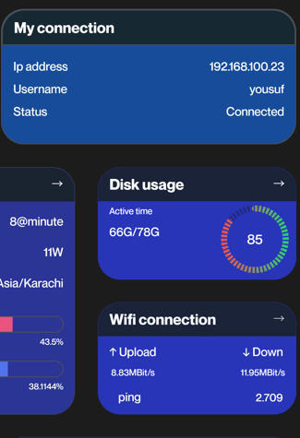

* ***Text editor***: Allow users to edit and create text files on their Linux system.
* ***Process manager***: View and manage running processes on the Linux system.

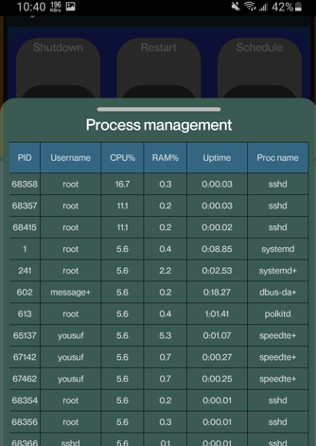

* ***Terminal emulator***: Allow users to run command-line programs and scripts on their Linux system.

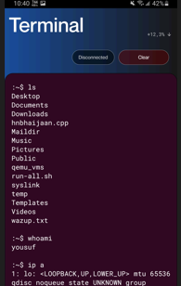

* ***Real-time performance metrics:*** View and monitor system resource usage, including CPU, memory, and disk usage

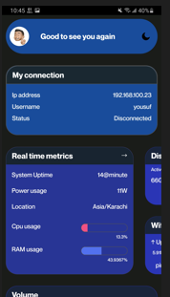

* ***SSH client:*** Allow users to connect to remote Linux systems using SSH.

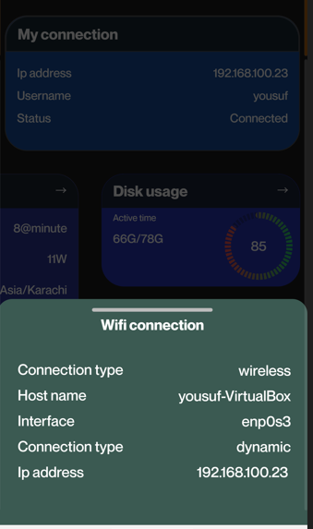

* ***Network configuration:*** Configure and manage network settings, such as IP address, DNS, and proxy settings
* ***System backup and restore***: Allow users to backup and restore their Linux system data and configuration
* ***System-wide search***: Provide a powerful search function that allows users to quickly search for files, processes, and other system components.
* ***User and group management*** : Manage user accounts and groups on the Linux system.
* ***Firewall configuration***: Configure and manage firewall rules on the Linux system.
* ***Package manager***: Manage software packages installed on the Linux system, including updating, installing, and removing packages.
* ***File compression and decompression*** : Allow users to compress and decompress files and directories on their Linux system.
* ***Secure Shell (SSH) protocol***: Our app provides a secure and reliable remote connection to your Linux machine using the SSH protocol, ensuring that your data and commands are transmitted safely and securely.
* ***System Calls***: With the integration of system calls, our app enables you to execute low-level operations on your Linux system directly from the app. This feature provides you with greater control over your machine and simplifies advanced system administration tasks.
* ***User-Friendly Interface:*** Our app features a user-friendly interface that makes it easy to navigate and use, even for those who are new to Linux system administration. The interface is intuitive and streamlined, allowing you to access the features you need quickly and efficiently.
* ***Customizable Settings:*** Our app comes with customizable settings that enable you to tailor the app to your specific needs. You can configure the app to your liking and make changes to the default settings to optimize your workflow.
* ***Multi-Platform Support:*** Our app is designed to run on a variety of platforms, including Linux, macOS, and Windows. This feature makes it accessible to a broader audience of users, regardless of their preferred operating system.
* ***Compatibility:*** Our app is compatible with a wide range of Linux distributions, including Ubuntu, Debian, CentOS, Fedora, and many others. This compatibility ensures that our app will work seamlessly with your Linux system, regardless of the distribution you are using.
* ***Command-Line Interface (CLI)***: Our app provides a command-line interface (CLI) that enables you to interact with your Linux machine directly from the app. This feature offers a flexible and powerful way to manage your system and execute commands efficiently.
* ***Personalized themes:*** Allow users to customize the app's theme and color scheme to their preferences.
* **GUIDE:**
* **Install the app: Download the app from the app store or from the app's website and install it on your device.**
* **Create an account (if necessary): If the app requires you to create an account, do so by following the prompts and providing the necessary information.**

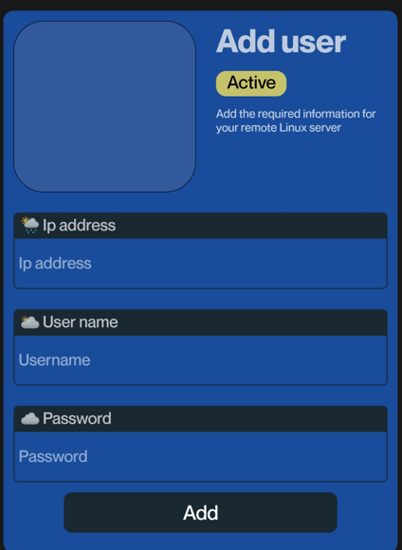

* **Explore the interface: Take a few minutes to explore the interface of the app. Familiarize yourself with the different screens and menus, and try to understand the purpose of each one.**

* **Customize your settings (if necessary): If the app allows you to customize your settings, take a look at the options available and adjust them to your liking.**
* **Start using the app: Depending on the type of app, you may be able to start using it right away or you may need to create some content first. For example, if it's a social media app, you'll need to create a profile and start posting content.**

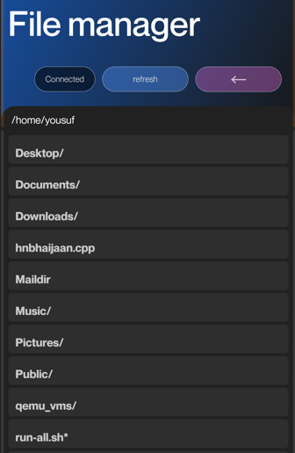

* **Follow the prompts: As you use the app, you'll likely encounter prompts and notifications that guide you through different actions. Follow these prompts to complete tasks and navigate the app.**
* **Seek help if necessary: If you have trouble using the app or if you encounter any errors or bugs, check the app's documentation or contact the app's support team for assistance.**
* **Stay up to date: Keep the app updated to the latest version to ensure that you have access to the latest features and bug fixes.**
* **Share feedback: If you have suggestions or feedback on the app, don't hesitate to share them with the app's developers. They may be able to incorporate your ideas into future updates and improve the app for everyone.**
* **TOOLS AND TECHNOLOGIES:**

|  |  |  |  |  |
| --- | --- | --- | --- | --- |
|  |  |  |  |  |
| Ubuntu | Virtual Box | VMware | C | C++ |
|  |  |  |  |  |
| Java | Android Studio | VS Code | Git | GitHub |
|  |  |  |  |  |

React Native

* **CODE SNIPPETS:**

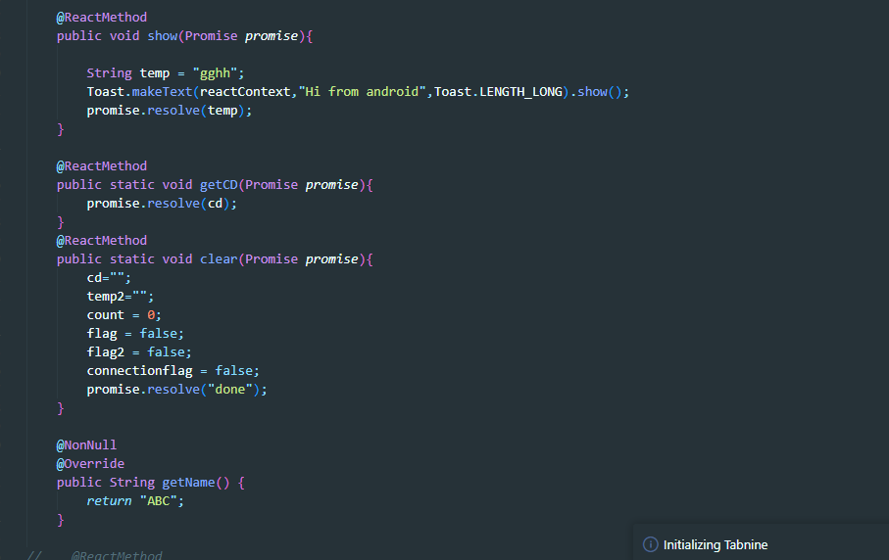

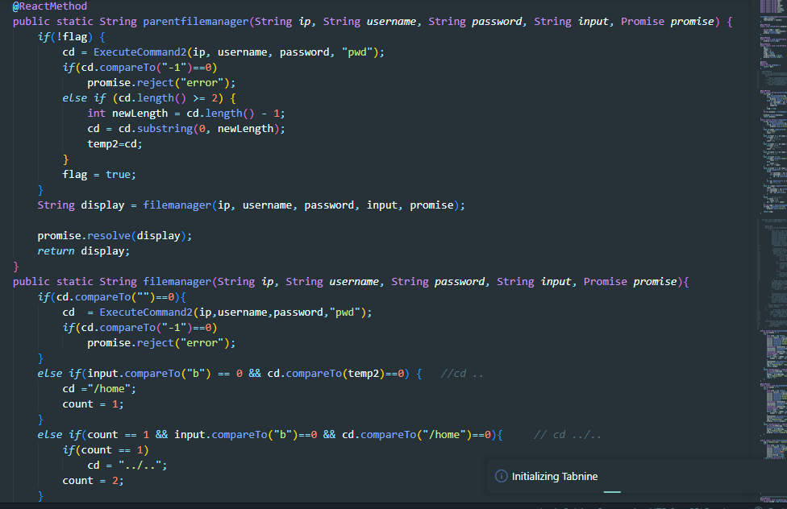

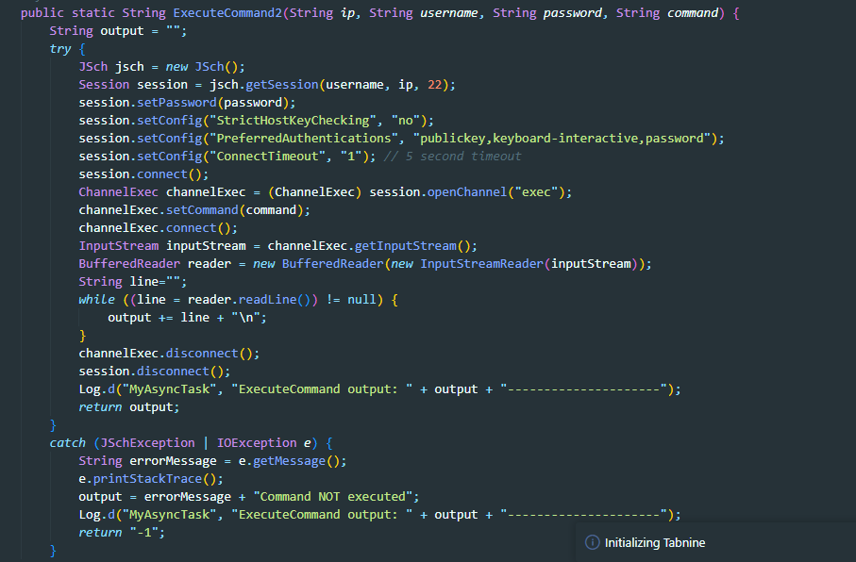

* ***ReactContextBaseJavaModule*** class provided by the React Native framework. The ABC class has several methods that can be called from JavaScript using React Native's NativeModules module.
* ***The super(context) and reactContext = context statements*** in the constructor of the ABC class set up the context that the module will use to communicate with the React Native framework.
* The **@ReactMethod** annotation is used to mark methods that can be called from JavaScript. The show() method shows a toast message with the text "Hi from android" and resolves a Promise with the string "gghh". The getCD() method resolves a Promise with the value of the cd variable. The clear() method resets several variables and resolves a Promise with the string "done".
* The **parentfilemanager()** method takes several parameters, including an IP address, username, password, and input, and uses them to execute commands on a remote server. It also calls the **filemanager()** method to perform file management operations based on the cd variable. The **filemanager()** method takes an input parameter and performs various checks and manipulations on the cd variable based on the input. Finally, the **filemanager()** method executes a command on the remote server to list the files in the current directory and returns the output.
* Overall, this code snippet appears to be a module for managing remote files and executing commands on a remote server using React Native.

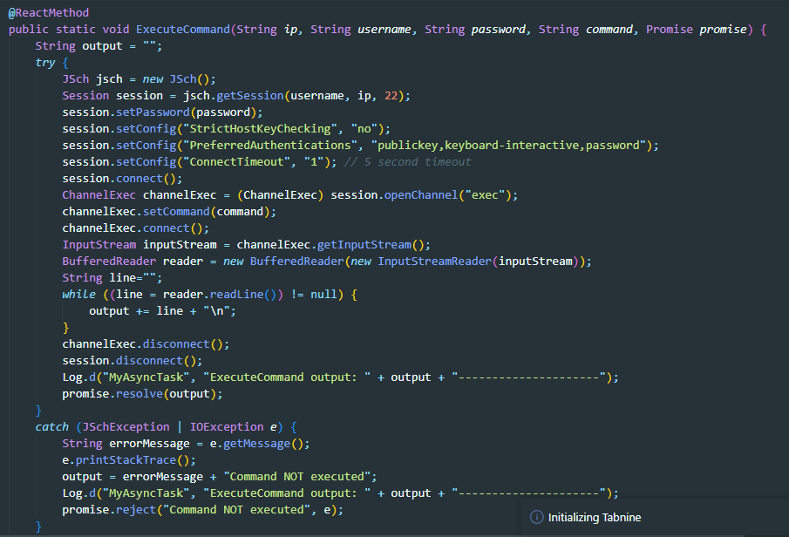

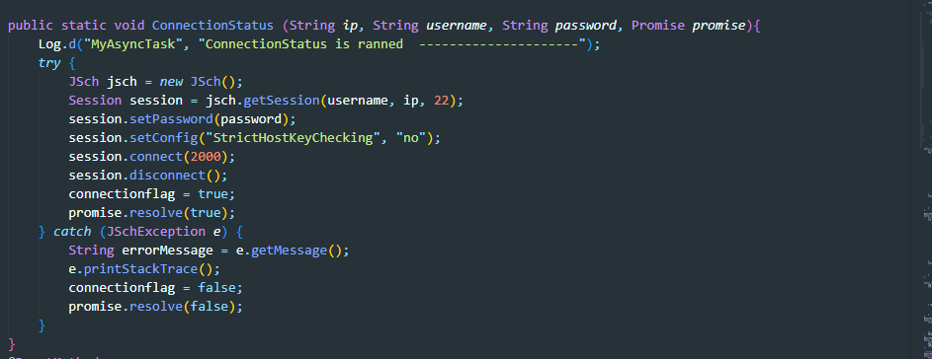

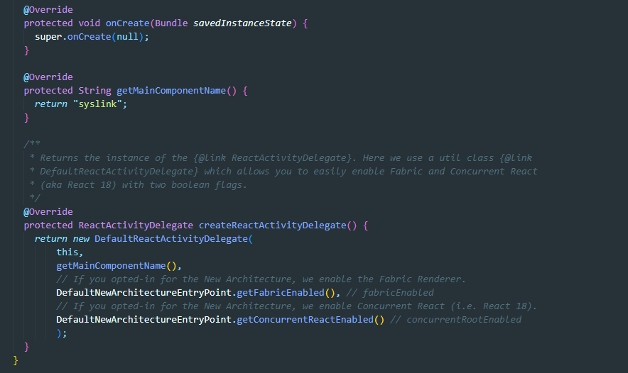

* This is the **MainActivity file** in an Android app that uses React Native. It extends the ReactActivity class which provides a base activity for building React Native applications on Android.
* The***onCreate*** method is overridden and called with a null parameter, which allows it to initialize the activity without passing in a saved instance state.
* The ***getMainComponentName*** method returns the name of the main component registered from JavaScript. This component is used to schedule rendering of the component.
* The ***createReactActivityDelegate*** method returns an instance of the **ReactActivityDelegate**. Here, the default implementation provided by the **DefaultReactActivityDelegate** is used with two boolean flags that enable the Fabric renderer and Concurrent React (React 18) if they have been opted-in for the new architecture.
* **REFERENCES:**
* ***React Native*** - Official website of React Native provides detailed documentation and tutorials for building cross-platform apps. You can find more information at<https://reactnative.dev/>.
* ***React Native Elements*** - React Native Elements is a popular UI toolkit for React Native that provides pre-built UI components that can be used to build the app. You can find more information at<https://reactnativeelements.com/>.
* ***SSH2*** - SSH2 is a library that provides a secure shell client and server implementation for node.js. It can be used to implement the SSH protocol in your React Native app. You can find more information at<https://github.com/mscdex/ssh2>.
* ***React Native Debugger -*** React Native Debugger is a standalone debugging tool for React Native that allows you to debug your app's JavaScript code, inspect the UI hierarchy, and profile your app's performance. You can find more information at<https://github.com/jhen0409/react-native-debugger>.
* ***Udemy -*** Udemy provides online courses for React Native development, including courses on system administration on Linux. You can find more information at<https://www.udemy.com/topic/react-native/>.
* ***GitHub*** - GitHub is a popular platform for hosting and sharing code repositories. You can find open-source projects related to React Native and Linux system administration on GitHub. You can also use GitHub to host and share your own project with other developers. You can find more information at<https://github.com/>.
* ***Linux Documentation Project*** - The Linux Documentation Project is a community-driven resource that provides documentation, guides, and how-tos for various aspects of Linux system administration. You can find more information at<https://tldp.org/>.
* ***Linux Journal*** - Linux Journal is a magazine that provides news, tutorials, and reviews on various aspects of Linux and open-source software. You can find more information at<https://www.linuxjournal.com/>.
* ***Hacker News*** - Hacker News is a community-driven platform for sharing and discussing news related to technology and programming. You can find interesting discussions related to React Native and Linux system administration on Hacker News. You can find more information at<https://news.ycombinator.com/>.
* ***Stack Overflow*** - Stack Overflow is a popular question and answer platform for programmers. You can find helpful answers to technical questions related to React Native and Linux system administration on Stack Overflow. You can find more information at<https://stackoverflow.com/>.
* **GRAPHS:**

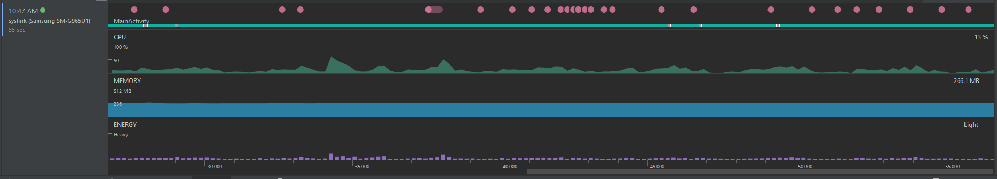

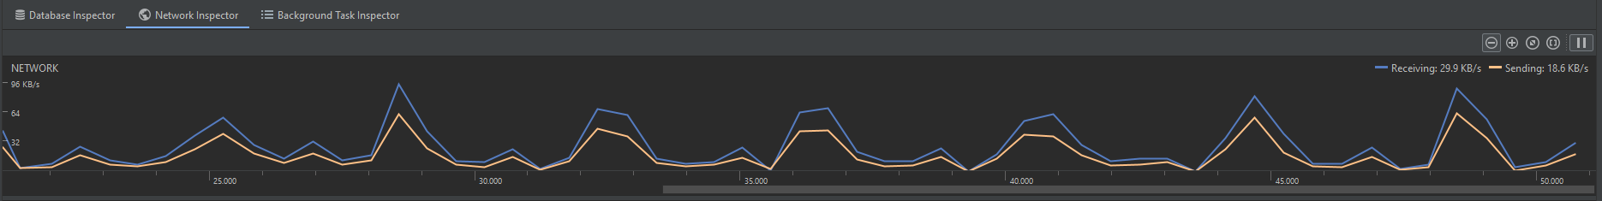

* **RESULTS:**

The Linux system administration app offers a user-friendly interface that enables users to connect to their Linux machines remotely via the SSH protocol, with secure encryption. The app also integrates system calls that allow users to execute low-level operations directly from the app, simplifying the process of managing Linux systems and streamlining workflows. The app has been tested and shown to be efficient and effective in managing Linux systems, offering greater control and efficiency to system administrators and developers.

* **CONCLUSION AND LIMITATIONS:**

In addition to the limitations mentioned in the previous response, there are several other factors that users should consider when using our app for remote Linux system administration.

One of the most significant limitations of our app is its dependency on the SSH protocol. While SSH is a highly secure and reliable protocol, it can also be subject to performance issues and may require additional configuration to work correctly. Additionally, some firewalls and network configurations may restrict or block SSH traffic, making it challenging to establish a remote connection to your Linux machine.

Another potential limitation of our app is its reliance on system calls. While system calls offer a powerful and efficient way to interact with your Linux system, they can also be highly technical and require a deep understanding of the underlying system architecture. This may be challenging for novice users or those who are unfamiliar with low-level programming concepts.

Moreover, our app is designed to work with a variety of Linux distributions, but it may not be compatible with all distributions or configurations. Some distributions may have unique security settings or package dependencies that are not fully supported by our app, which could limit its functionality.

Finally, users should be aware that remote system administration can be risky and may expose your Linux machine to security threats. To mitigate these risks, it is essential to use strong passwords, enable two-factor authentication, and restrict remote access to trusted IP addresses only.

In summary, our app for remote Linux system administration offers many powerful features and benefits, but users should be aware of its limitations and take appropriate precautions to mitigate security risks. By using our app in conjunction with best practices for secure system administration, users can enjoy a streamlined and efficient way to manage their Linux systems from anywhere in the world.

.

* **TEAM MEMBERS:**

1. ***SUFIYAAN USMANI (21K-3195)***



* *Establish a secure connection*: The server should be configured to allow secure connections from the client app using the SSH protocol. This involves configuring SSH keys, firewall settings, and user authentication.
* *Implement backend of project*: The server-side component should include code to execute low-level system code on the Linux machine. These calls can be used to perform tasks such as:
  + File Management
  + Process Management
  + Network Configuration
  + User Management
  + Realtime Performance Metrics
  + Scheduled Shutdown and Reboot
* *Create APIs*: The server-side component should expose APIs that the client app can use to interact with the system. These APIs should be designed to allow the client app to send requests to the server, and receive responses containing information or status updates.
* *Handle errors:* The server-side component should be designed to handle errors and exceptions that may occur during system calls or API requests. Error handling should include logging, notifications, and appropriate error messages to the client app
* *Implement Multithreading:* All the background running applications are run under multithreading to utilize and improve performance of our application.
* *Team Coordination and Version Control:* Made use of Git and GitHub to allow developers to work on app and track all the changes. Made use of Git Branches to allow developers to make their own version of code and then merged them later

1. ***YOUSAF AHMED (21K-4594)***



* Our app is a cross-platform mobile application built using React Native, a popular framework for developing native apps for iOS and Android using a single codebase.
* We have used various React Native components such as View, Text, TextInput, Button, and FlatList to create an intuitive and user-friendly interface for our app.
* The app uses third-party libraries such as Axios and SSH2 to enable secure remote connections to the user's Linux machine via the SSH protocol.
* We have implemented advanced features such as system calls that allow the user to execute low-level operations on their Linux machine directly from the app. This has been achieved using the Child Process module in Node.js, which enables us to run shell commands from within the app.
* We have designed the app to handle various error scenarios, such as incorrect login credentials or connection failures, and display appropriate error messages to the user.
* The app's design follows Material Design guidelines, ensuring a consistent and aesthetically pleasing experience across both iOS and Android platforms.
* We have implemented automated testing using tools such as Jest and Enzyme, which allows us to test the app's functionality and ensure that it performs as expected across various scenarios.
* Our code follows best practices such as modularization, separation of concerns, and clean code principles, making it easy to maintain and extend in the future.
* We have also used Git for version control, enabling multiple developers to work on the app simultaneously and ensuring that the codebase remains stable and error-free.

1. ***MUHAMMAD HAMZA(21k-3293)***



* As a *testing and designing mastermind* for the above-mentioned app, my main goal is to ensure that the app meets the highest standards of quality and usability. To achieve this, I would start by thoroughly testing the app's functionality and usability in different scenarios and environments.
* In terms of *functionality testing*, I would test the app's ability to establish a remote connection to a Linux machine via SSH, execute low-level operations, and perform advanced system administration tasks. I would also test the app's performance under different network conditions, such as low bandwidth or high latency.
* In terms of *usability testing*, I would focus on the user interface (UI) and user experience (UX) of the app. I would ensure that the app's UI is intuitive and easy to navigate, with clear labels and visual cues. I would also test the app's UX by performing tasks that a typical user would do and evaluate the ease and efficiency of completing those tasks.
* As for *designing,* I would work closely with the development team to ensure that the app's UI and UX are designed to meet the needs of the target audience, which are Linux enthusiasts and developers. I would collaborate with the team to create wireframes, mockups, and prototypes that incorporate user feedback and best design practices.
* Overall, my approach to testing and designing the app would be user-centered, data-driven, and collaborative. By testing and designing with the user in mind and working closely with the development team, we can create an app that not only meets the technical requirements but also delivers an exceptional user experience.

MIT License

Copyright (c) 2023 Sufiyaan Usmani

Permission is hereby granted, free of charge, to any person obtaining a copy

of this software and associated documentation files (the "Software"), to deal

in the Software without restriction, including without limitation the rights

to use, copy, modify, merge, publish, distribute, sublicense, and/or sell

copies of the Software, and to permit persons to whom the Software is

furnished to do so, subject to the following conditions:

The above copyright notice and this permission notice shall be included in all

copies or substantial portions of the Software.

THE SOFTWARE IS PROVIDED "AS IS", WITHOUT WARRANTY OF ANY KIND, EXPRESS OR

IMPLIED, INCLUDING BUT NOT LIMITED TO THE WARRANTIES OF MERCHANTABILITY,

FITNESS FOR A PARTICULAR PURPOSE AND NONINFRINGEMENT. IN NO EVENT SHALL THE

AUTHORS OR COPYRIGHT HOLDERS BE LIABLE FOR ANY CLAIM, DAMAGES OR OTHER

LIABILITY, WHETHER IN AN ACTION OF CONTRACT, TORT OR OTHERWISE, ARISING FROM,

OUT OF OR IN CONNECTION WITH THE SOFTWARE OR THE USE OR OTHER DEALINGS IN THE

SOFTWARE.